Primary Replica Snippets with commands

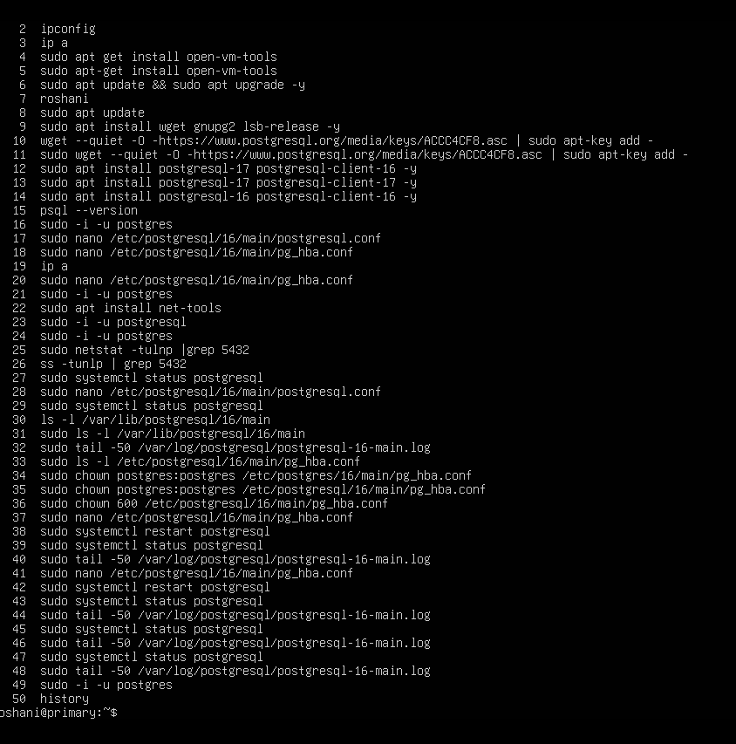

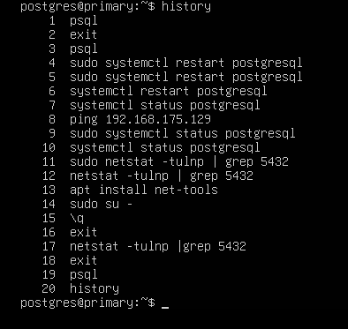

Replica VM snippet commands:

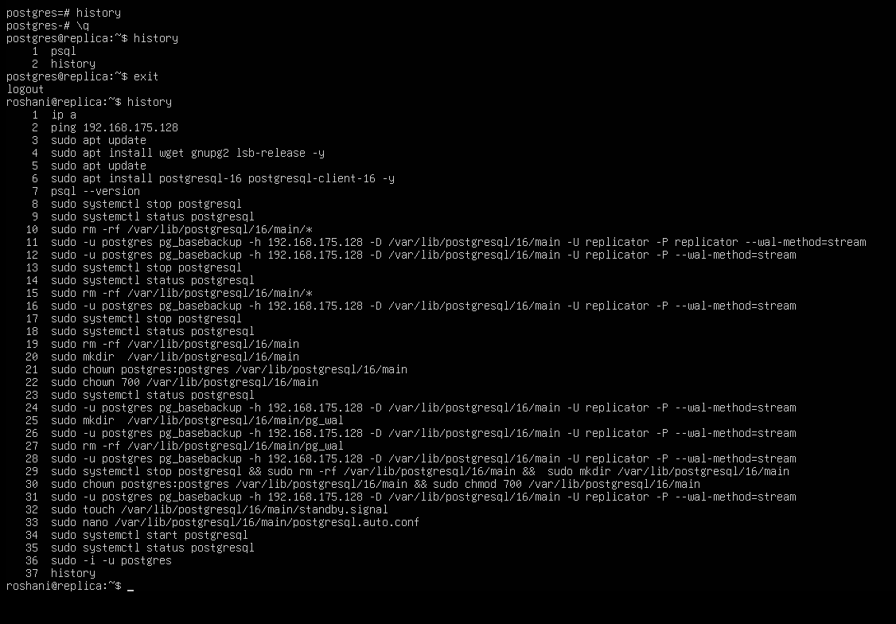

**1.Replication Status check from primary VM**

SSH/login into your **Primary VM** and run:

Sudo -i -u postgres

psql

SELECT client_addr, state, sync_state, write_lag, flush_lag, replay_lag

FROM pg_stat_replication;

From replica:

SELECT pg_is_in_recovery();

sudo systemctl stop postgresql

**2: From Replica VM (Standby) promoting it as Primary replica by failover:**

sudo -i -u postgres

pg_ctl promote -D /var/lib/postgresql/16/main

psql

SELECT pg_is_in_recovery();

**f = false** → means Replica is no longer in recovery → it's now **acting as Primary**.

CREATE TABLE demo_failover(id INT);

INSERT INTO demo_failover VALUES (1);

SELECT * FROM demo_failover;

**Master username**

Postgres

**AWS RDS Demo for Failover**

(Due to free tier subscription of AWS limited features were available for demonstrating the study)

**1.Created two VM in different region**

Primary VM - roshani-1.cf4g24se079r.eu-north-1.rds.amazonaws.com

Replica VM - roshani-replica.cf4g24se079r.eu-north-1.rds.amazonaws.com

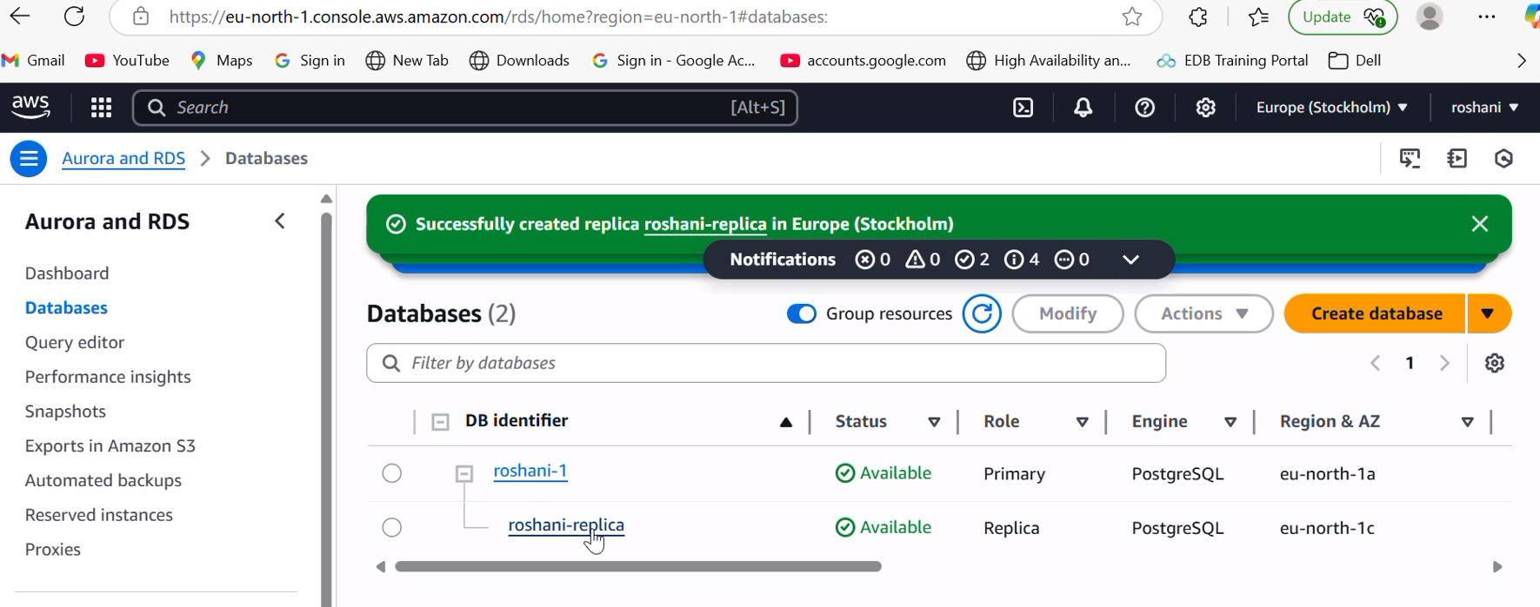

**2. Security configurations for allowing connections to the machines created via PGADMIN tool**

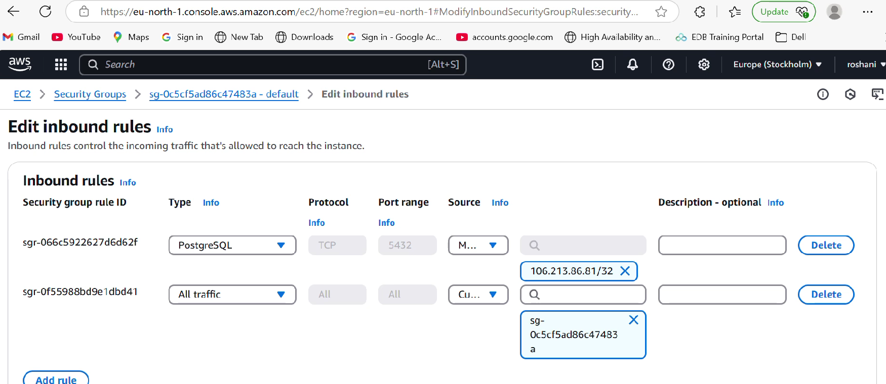

**3.Accessing VM’s created through PGAdmin tool for testing and validation**

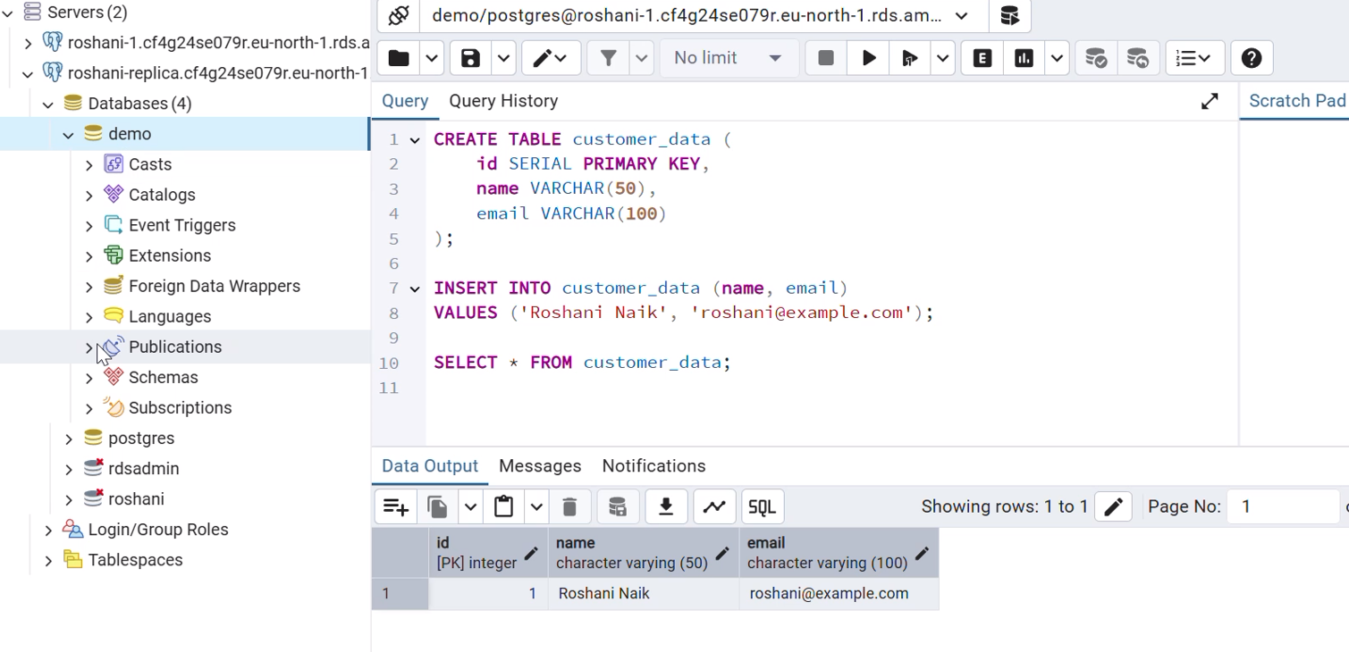

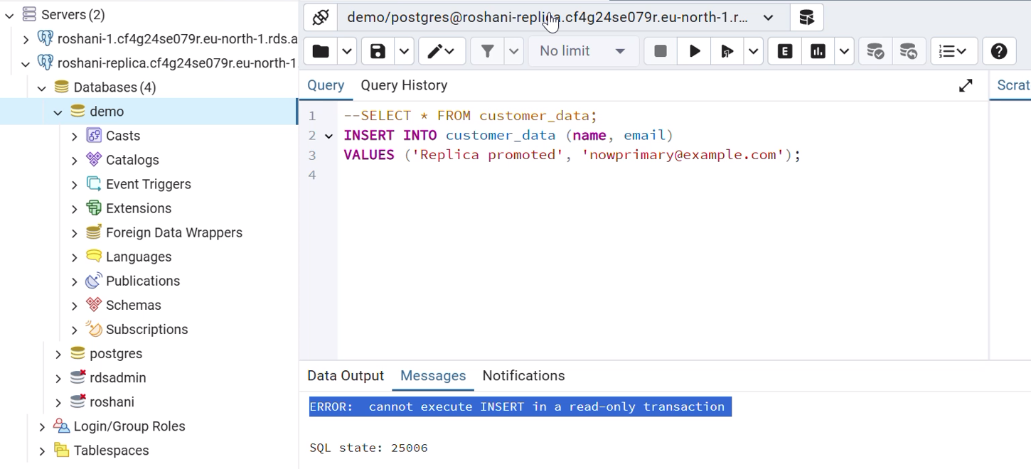

**4. Promoting the replica read only VM to be primary for read write connections**

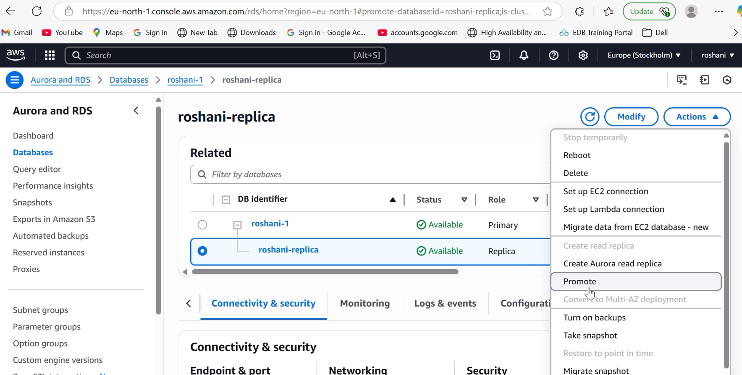

**5.Replica VM promoted to Primary accepting write operation**

